ECA56 – ADVANCED WIRELESS COMMUNICATION SYSTEMS
EXPERIMENT 1
Simulation and Comparative Analysis of FDMA, TDMA and CDMA
Prepared by: p.sridhar
AIM
To simulate FDMA, TDMA and CDMA multiple-access techniques and compare their estimated user capacity and CDMA signal-to-interference ratio (SIR).
APPARATUS / SOFTWARE REQUIRED
Computer with MATLAB Online/Desktop. No physical hardware is required; this is a software simulation.
MATLAB / ARDUINO CODE
clc;
clear;
close all;
% EXPERIMENT 1: FDMA, TDMA and CDMA comparison
totalBandwidthHz = 1e6;
fdmaChannelHz = 200e3;
tdmaSlots = 8;
processingGain = 64;
targetSIRdB = 7;
% Estimated user capacities
fdmaUsers = floor(totalBandwidthHz/fdmaChannelHz);
tdmaUsers = tdmaSlots;
targetSIR = 10^(targetSIRdB/10);
cdmaUsers = floor(1 + processingGain/targetSIR);
fprintf('FDMA Users: %d\n',fdmaUsers);
fprintf('TDMA Users: %d\n',tdmaUsers);
fprintf('CDMA Users: %d\n',cdmaUsers);
methods = categorical(["FDMA","TDMA","CDMA"]);
methods = reordercats(methods,["FDMA","TDMA","CDMA"]);
users = [fdmaUsers tdmaUsers cdmaUsers];
figure;
bar(methods,users);
grid on;
xlabel('Multiple Access Technique');
ylabel('Estimated Users');
title('FDMA, TDMA and CDMA Capacity Comparison');
% CDMA SIR versus number of simultaneous users
K = 2:30;
sirLinear = processingGain./(K-1);
sirDb = 10*log10(sirLinear);
figure;
plot(K,sirDb,'o-','LineWidth',1.5);
hold on;
yline(targetSIRdB,'r--','Target SIR');
grid on;
xlabel('Number of Simultaneous Users');
ylabel('SIR (dB)');
title('CDMA SIR versus Number of Users');
legend('Estimated SIR','Target SIR','Location','best');
OUTPUT SCREENSHOTS
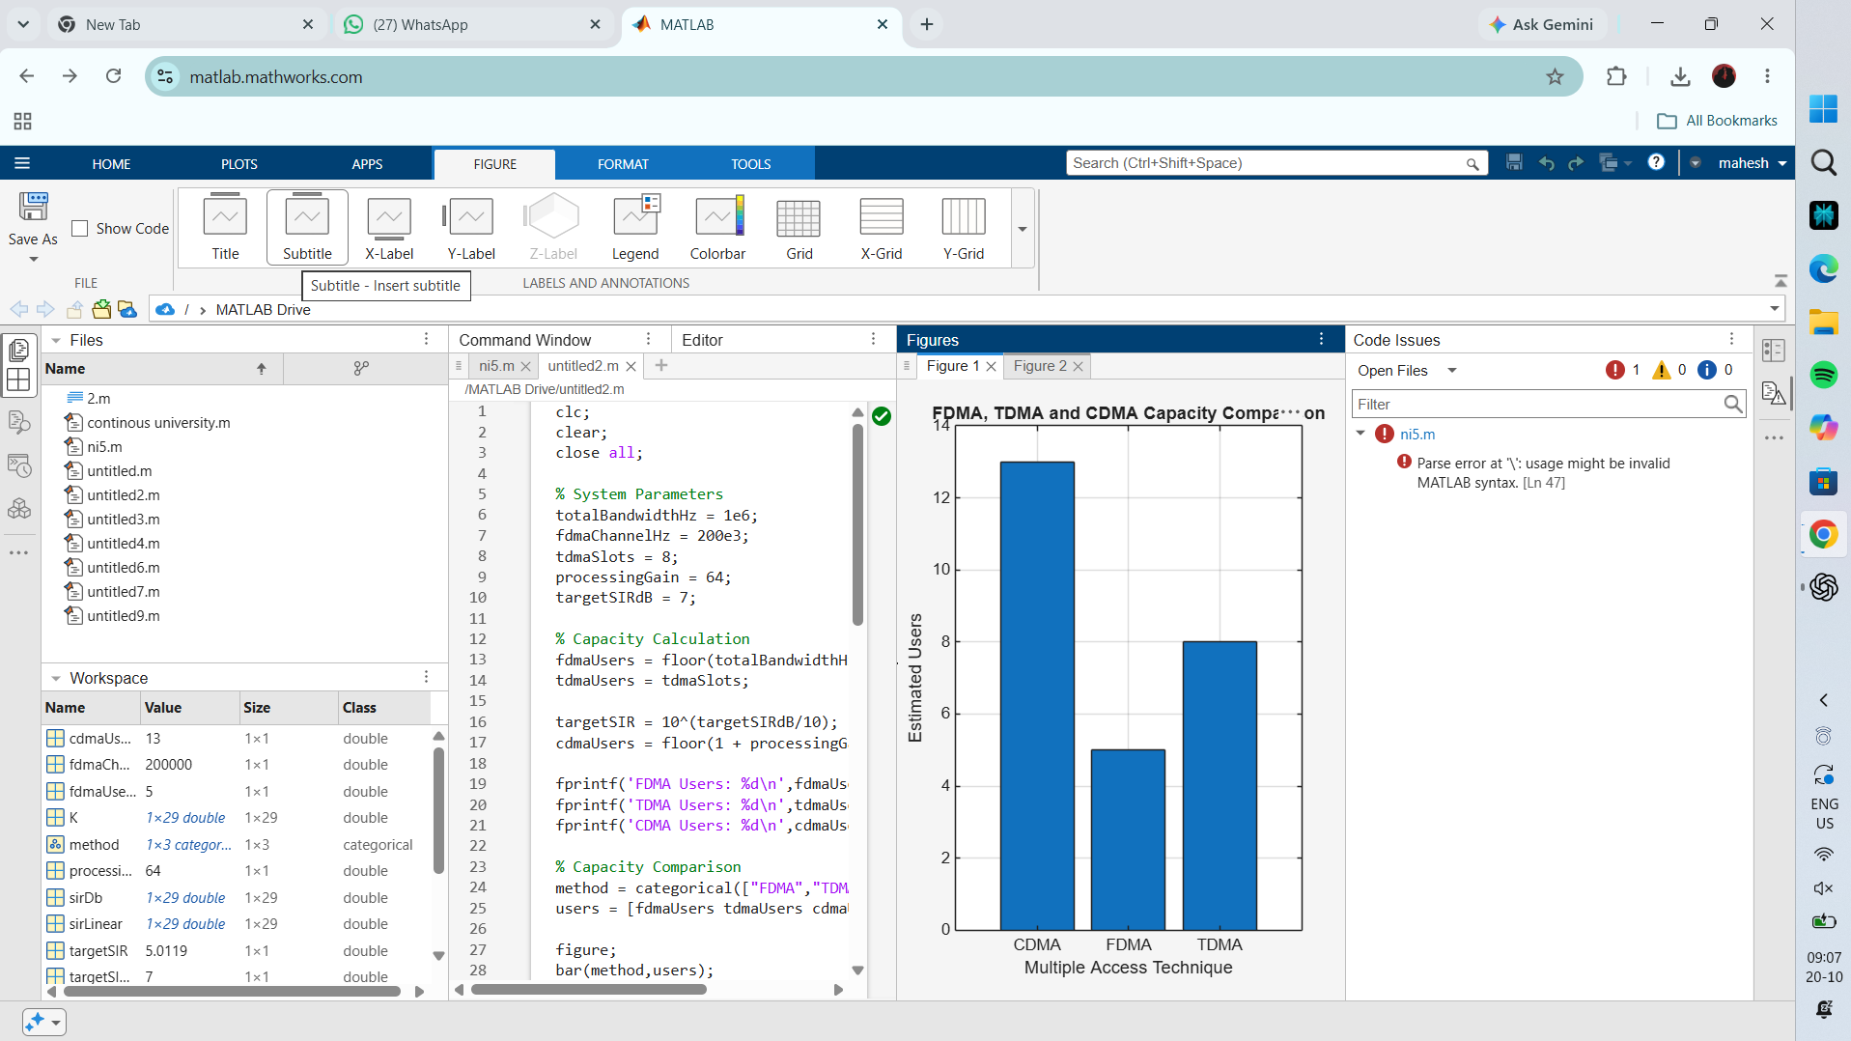
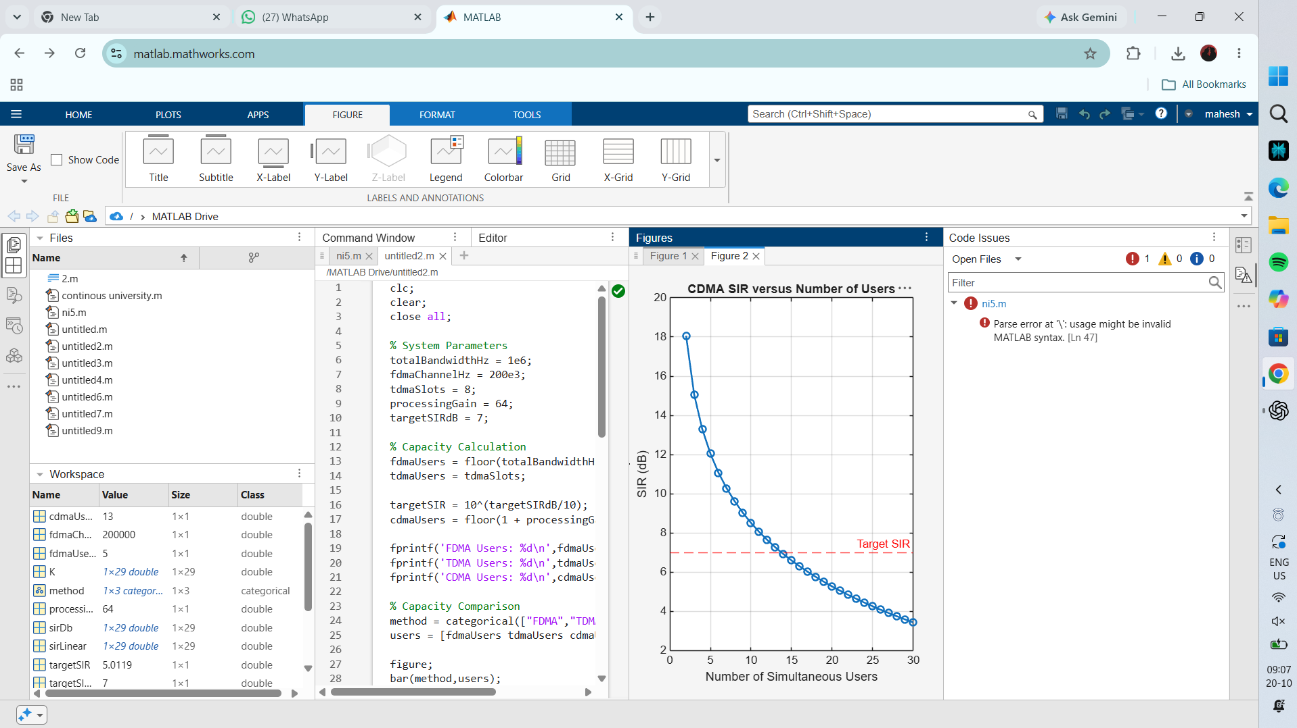
RESULT
The simulation compares estimated user capacity for FDMA, TDMA and CDMA and plots the reduction in CDMA SIR as the number of simultaneous users increases.

